Marvin Natiss  Mayor  Dennis Sgambati  Deputy Mayor  Elliott Arnold  Phyllis Lentini  Gail J. Cohen  Trustees  (516) 627-3451  Fax (516) 627-0703 | Village of North Hills  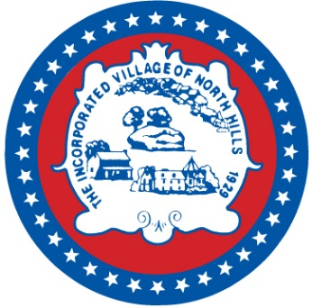 | Marianne C. Lobaccaro, MMC  Village Administrator  A. Thomas Levin  Village Attorney  Peter A. Cinquemani, R.A.  Superintendent of the Building Department  www.villagenorthhills.com
 | One Shelter Rock Road, North Hills, N.Y. 11576
Message from Mayor Marvin Natiss
Dear residents,
I hope this letter finds everyone well and ready to enjoy the spring and summer seasons. The Lowell H. Kane Village Park on I. U. Willets Road has been completely refurbished. The park is available to Village Residents and their guests from dawn until dusk. The Board of Trustees meets at Village Hall at 7:30 p.m. on the third Wednesday of every month and all are welcome.
The Village continues to provide a commuter shuttle service for Village Residents from Village Hall to the Manhasset Train Station. We encourage our residents to utilize this complimentary service and have ample parking available at Village Hall. All riders must show a valid pass to board the shuttle. Village Hall is open 9 - 5 weekdays for issuance or renewal of shuttle passes. A current schedule is posted on the Village website.
Please be advised that additions, renovations, and repairs, including any building, electrical, or plumbing work, require a permit from the Village Building Department. Please contact the Village before commencing work.
I would like to take this opportunity to thank Deputy Mayor Dennis Sgambati, Trustee Phyllis Lentini, Trustee Elliott Arnold, and Trustee Gail Cohen for their diligent service to the Village of North Hills.
Mayor Marvin Natiss
mayor@villagenorthhills.com

